Analysis of Gramin Kalyan Yojana Meeting Participation

An Analytical Report on Demographic Engagement and Age Group Participation Trends in the Gramin Kalyan Yojana Meetings.

Submitted by: Aditya Kumar Chaudhary

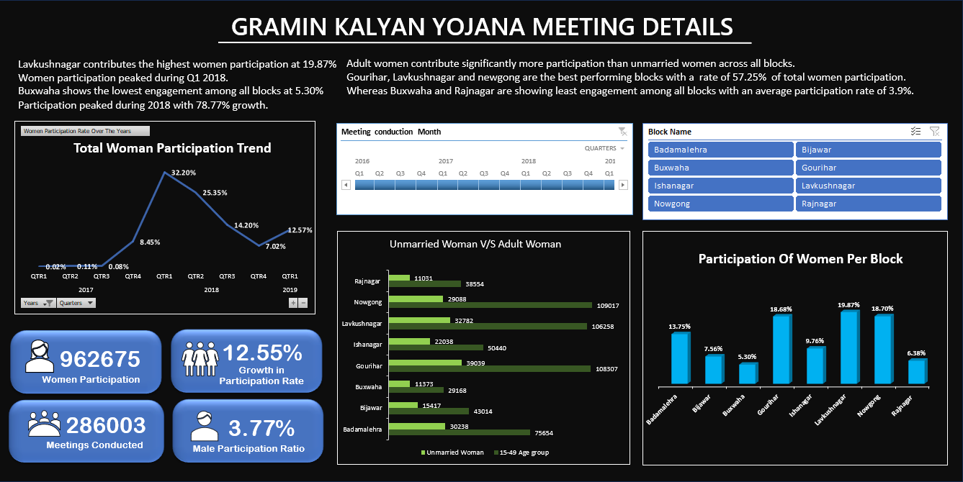

1) Executive Summary

The objective of this report is to present insights on meetings conducted in different blocks of Chhatarpur to find observations and derive meaningful patterns.
The meetings were conducted from quarter 4 of 2016 to quarter 1 of 2019. The meeting was held in 8 blocks Chhatarpur.
The study primarily focuses on identifying participation trends, regional trends, engagement patterns between different sections of society and their growth and involvement in awareness campaigns.
The analysis revealed that Lavkushnagar, Gourihar and Newgong beat all other blocks in terms of turnout with an average turnout of 19%.
Whereas Buxwaha and Raj Nagar emerged as blocks with lowest participation of women in these meetings.
Also trend analysis indicated a substantial growth of women participation in the year of 2018 with peak participation in quarter 1. The data further highlighted that the other women age group showed higher interest in participation as compared to unmarried women.
Based on the findings, the report indicates that we should encourage the people of low performing blocks and implement steps by replicating steps taken in high performing blocks, also we should give careful attention to the overall demographic region for a better outreach and information spread.

2) Introduction
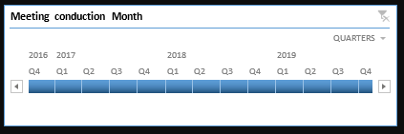
From quarter 4 of 2016 to quarter 1 of 2019 awareness campaigns and meetings were conducted to raise awareness and make women empowered.
Based on that every meeting was noted and a proper document was prepared which consisted of the number of women participants (along with all age group consideration) , number of man participants meeting number block and meeting conduct date along with supervisor who led the meeting.
The main objective of these meetings was to raise awareness and spread information regarding multiple government schemes that are ongoing into their areas and how they can avail those.

3) Problem Statement

Identification of the regional and demographic participation trends of different age groups of women and their year-on-year rate of participation in Gramin Kalyana Yojana meetings.

4) Objectives of analysis

- Finding high and low performing blocks
- To identify women participation in the meeting
- To identify growth of these meeting over the time
- To study changes in demographic participation distribution through meetings.

5) Data Collection & Sources

Database primary collected through Google forms and was also recorded when meetings were held.
After that data was cross checked to find if any discrepancy was present in it or not.

6) Data cleaning & preparation

- Removal of duplicate
Firstly, the data was taken and then it was cleaned by removing the duplicates and dropping null values from the dataset.
Then structure the data into a proper table format with proper data types specified (date, number, text, etc.)

7) Tools & technologies used

- Microsoft Excel
- Pivot chart
- KPI cards
- Pivot tables
- Slicer
- Data Visualisation Technique

8) Methodology

First pivot tables were used to depict the pattern between different attributes.For example, pivot table showing participation trend of unmarried women v/s women with age group 15-49.

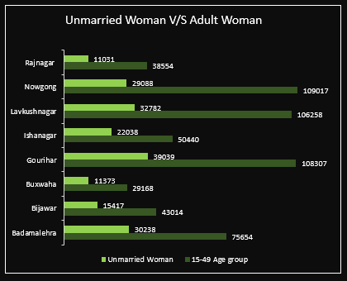

Also, from that pivot table bar chart was created indicating real time data comparison of participation of different categories.
After that KPI cards were systematically calculated by applying formulas. For example, the man participation rate was determined by taking total men participation by total women participation.
There is a line chart above KPI cards showing trends of women participation in different quarters over the years.
Also block comparison charts indicate blocks that are under performing as well as those blocks which emerged as major contributors.
Segmented approach is used as a large data set is broken into smaller segments of data for careful observation and use of relevant data for particular research. For example, blocks were considered for counting women participation instead of using Chhatarpur (district)because that was not useful for that particular output.

9) KPI cards section

There are four KPI cards presented in the visualisation.

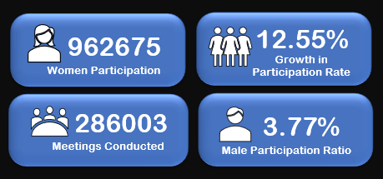

All of them carry significant details:
- The first KPI card indicated the total amount of women participation from beginning to end.
- The second KPI card indicates that there is a significant growth trend in women participation starting from a baseline of 0.02% in the year of 2016 to 12.57% in 2019.
- The third KPI card indicates the total number of meetings conducted which suggest the scale or outreach of the level of meeting executives.
- The last KPI card shows main participation with respect to women participation which indicates that not only women but men are also taking initiatives and showing their presence while attending those meetings.

10) Trend and Analysis

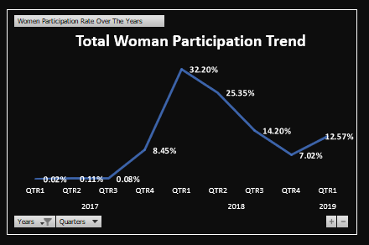

From quarterly participation data it can be derived that there is a trend in participation starting from quarter one of year 2017 with a rate of 0.02% and touching its peak in quarter one of 2018 with the rate of 32.2% of total participation whereas there was a sharp decline in the participation from quarter 1 2018 to quarter 4 2018 with the rate of participation going from 32.2% to 7.02%.

11) Demographic Analysis

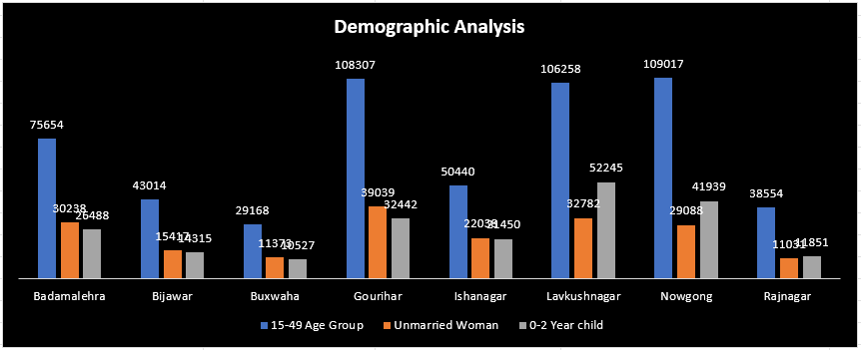

The largest participation was by adult women with a participation rate of 56% of overall participation.
After that age group of 0 to 2 years dominate the game with a participation rate of 21% of overall participation (this can be because all married women as well as other women prefer to carry their child with them when they leave for the meeting).
Then unmarried women contributed 19.12% of overall participation.
Then if we consider a man's participation then it will come out to be approximately 3.7% of total participation.

12) Geographic Analysis

Chart titled "participation of women per block” block wise participation can be clearly seen and understood. The luvkush Nagar block is the best performing block in these two years of time span and in contrast Buxwaha is the least performing block.

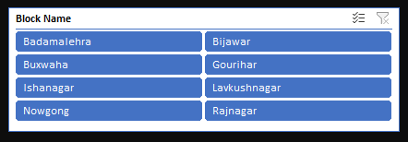

If we see clusters of Gourihar, Newgong and Luvkush Nagar blocks then these are the over performing blocks whereas the clusters of Buxwaha, Raj Nagar and Bijawar are under performing blocks.
In the given time span Badamlehra and Isha Nagar state with a neutral participation with an average rate of approximately 11% of entire participation.

13) Key Findings and recommendations

The research shows that the best performance was obtained in quarter one of 2018 and luvkush Nagar emerged as the best participating block with the rate of approximately 20% of total participation.
Adult females showed a higher interest in participation in those meetings and due to their interest, they sometimes carried their woman child (0-2 years age) which increased the participation rate of women child much more than unmarried women.
Man participation was slightly lower because they might be at work (job, farm, labour works, etc) & women participation dominated because most of the participants might be homemakers and it was not a hard task for them to attend a meeting which was just a few steps away from their home.

Suggestions:

- We should replicate strategies from high performing regions to low performing regions for their upliftment.
- We should consult the supervisor of high performing blocks and send them to low performing blocks for a better outreach.
- We can plan meetings on Sundays also so that everyone can participate in the meeting (As usually Sunday there is a week off).

14) Challenges and Limitations

There were many challenges which were coming in this analysis.
Data was enormous and labelled but there was absence of population normalisation.
Date was containing multiple null rows and some missing & null values.
Data was manually collected through Google forms so it can contain anomalies and the data may be altered by the person in charge.
The data was collected from a very limited regions so data may be biased as those regions may be women dominant in the terms of population.
Getting the data was also a challenge as the supervisor had manually recorded every meeting. Then they filled it in Google form so it was time consuming and a tedious task as each of them had conducted more than 200+ meetings.

15) Conclusion
So, the overall outcome of the research suggests that we should implement steps in Buxwaha Badamlehra and Rajnagar to increase awareness and participation after taking inspiration from high performing regions.
Also, some measures should be taken to balance the men to women participation ratio.

16) Future Scope

- In future Power BI should be used to display details more accurately using DAX queries and many of its features.
- We can use predictive analysis for predicting the strength of the next meeting based on these old data sets.
- GIS based mapping can be used in future for displaying data dynamically on maps.

17) References

Data Source: NGO (Bhopal, Madhya Pradesh). Field Study on Rural Development Participation, Chhatarpur District, 2016–2019.

